

CENTENNIAL COLLEGE PROGRESS CAMPUS

COURSE COMP125 Summer 2020

ASSIGNMENT #2

JavaScript Syntax (Loops)

Create an HTMLdocument called **assignment2.html** that implements a webpage that creates dynamically (using JavaScript code) a 15X15 HTML table and displays in each cell the (row, column) information for that cell.

Follow these guidelines to implement your assignment:

1. Create a JavaScript file called assignment2.js and write the code for a function that draws the table.
2. Invoke the function when the visitor clicks on the original page.
3. Load the assignment2.js file at the end of the body in assignment2.html.
4. (**10% of the grade**) Accept user input for the number of rows and columns in the table.
5. (**10% of the grade**) Use good web design practices to enhance visually your html page. Add a title, picture, colors, copyright line, etc.

Basic screenshots (for **80%, not including** guidelines #4 and #5 above) for the functionality of this assignment are shown below:

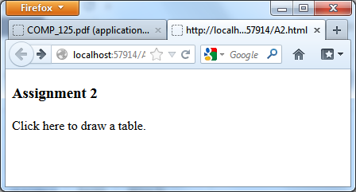



This assignment is **due on Fri. Jun. 19 at 10 pm**. **Late assignments are accepted two more days after the due date and they are marked out of 80%**.